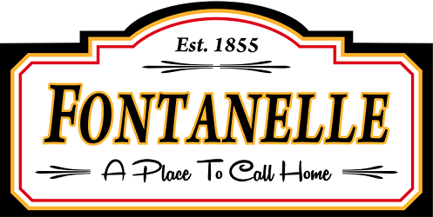
CITY OF FONTANELLE, IOWA
PUBLIC NOTICE OF COUNCIL MEETING AND AGENDA
Type of Meeting | Regular Monthly Meeting
Date of Meeting | Tuesday, May 12, 2026
Start Time of Meeting | 6:00 P.M. C.S.T.
Meeting Location | Fontanelle Community Center  219 Washington Street  Fontanelle, Iowa 50846

AGENDA ITEMS
- Call to Order
- Roll Call for Quorum.
- Pledge of Allegiance
- Opening Public Forum - Public input is welcome at our meetings. The council imposes a limit of three minutes per speaker.
5. Review and approve Consent Agenda Items:
a. Approve Agenda
b. Approve Minutes of Meetings held amended Mar 10, 2026, Apr 14, 2026 & Apr 21, 2026
c. Approve financial statements
d. Approve Bills for Payment

H & L Surveillance presentation re: cameras

Library compliance discussion, review and action.

DEPARTMENT REPORTS:
Notice is hereby given that the Council may discuss and/or approve certain actions or expenses presented to the Council during Department Reports.

- Mayor’s Report
- Council Report
- City Clerk’s Report
- Police Department
- Utility Department Report
- Library Report
(These items can be approved w/one motion, a second, and a roll call vote. Questions should be addressed before approval of the consent agenda. Council may vote to move items to the end of the agenda for further discussion.)

UNFINISHED BUSINESS:
- Community Center estimates
- USDA grant approval
- Community/Park camera estimate review
- Landfill increase Chapter 106
- 4TH Street water lines discussion

new business:

- Building permit 551 Edwin Place
- Building permit 204 Maple St
- Burn Variance 511 7th St
- Tobacco license renewal 304 Washington
- Sewer loan compliance audit.
- Yearly audit intention for State Auditor
- Encroachment agreement discussion
- Discuss and Act on any matter pulled from the Consent Agenda
- Items to be placed on Next Regular Meeting Agenda
- Next regular council meeting is June 9, 2026.
- Closing Public Forum - Public input is welcome at our meetings. The council imposes a limit of three minutes per speaker.
Notice is hereby given that the Council may review and amend or revise Council action taken on other agenda items previously discussed based on Public Input received during the Closing Public Forum.
- Adjournment

Posted 5/11/26 11 am

